* For the final thesis, about software engineering... I did use the circles.. first technique, implement one task, refine with animation, navigation... then second circle.... all task, all animations, all navigation.. .
* Tag one game object.. e.g. gamecontroller. And this controller can connect almost all the other necessary game objects... easy to get... i.e. find object by tag... and then get what it needs.
* Create a general script hashIDs to install all the hash ids for the animations. 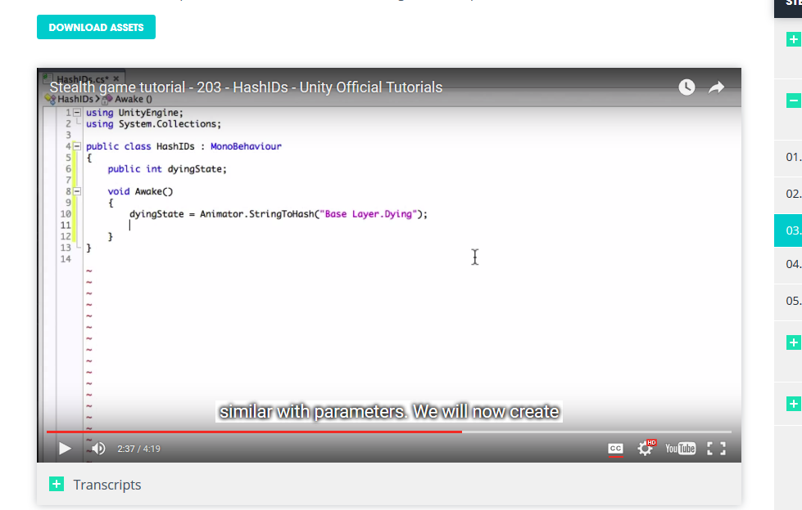
* Delegate the use function in toolcontroller